**Exercise 1: Setting Up Junit**

**Background:**

Firstly, we need to install VSCode and Java Extensions in the Editor. Then install the JUnit extensions. Once the setup is done, Write the code and start testing.

**Code:**

1. Make a file named, Greet.java and write the following code:

public class Greet{

public String says(){

return "Hello";

}

1. Make another file and name it GreetTest.java and write code:

import org.junit.*;

public class GreetTest {

@Test

public void test(){

Greet gre = new Greet();

Assert.assertEquals("Hello, World!", gre.greet());

}

}

1. Install JUnit using Jupiter and Debug and run above files and get the Output.

**Output:**

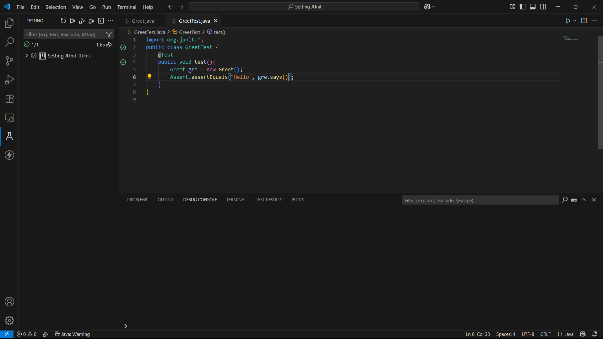

Fig. 1: Shows no errors.

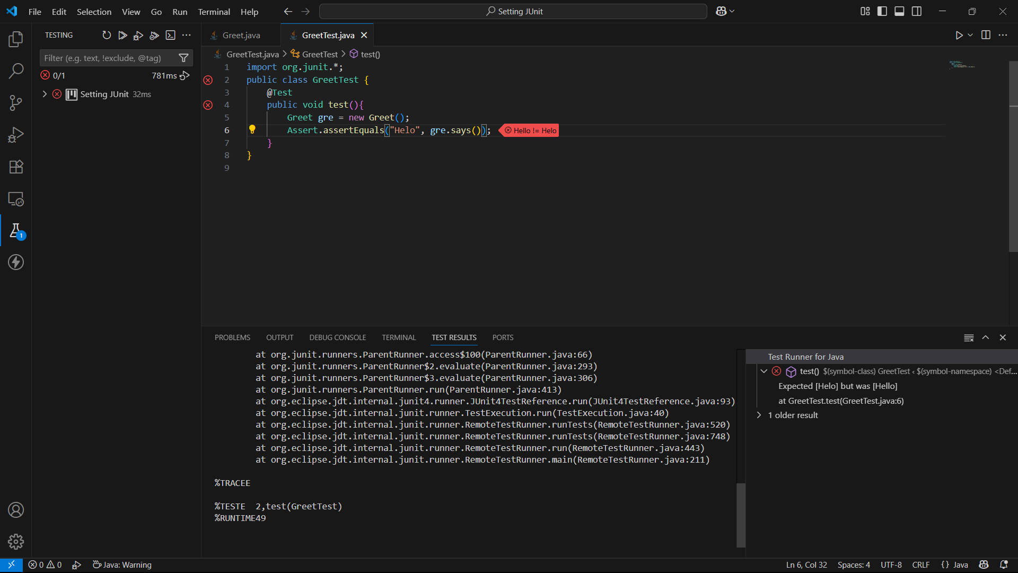

Fig.2: Code with errors.